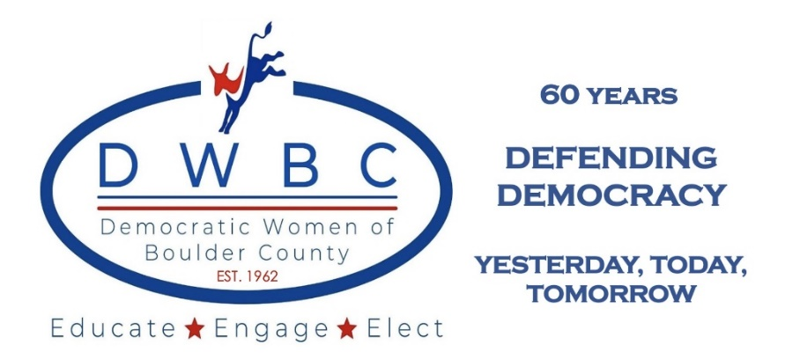

Anniversary Celebration – 60 Years of DWBC
Defending Democracy
Yesterday, Today, Tomorrow

May 17, 2023
The Avalon Ballroom, Boulder, CO
Celebration Agenda

6:00 Social
6:20 Opening Remarks – Lisa Lesniak and Video
6:30 Trivia Bowl on DWBC History
7:15 Adam Frisch, Candidate for US House CD3 and Nicole Hensel, Executive Director of New Era Colorado
7:45 Announce Winners for Special Prize
7:45 Secretary Jena Griswold
7:50 Legislative Wrap-up of 2023 Session
8:20 Closing Remarks

President’s Remarks

On behalf of this wonderful organization, thank you for joining us to celebrate 60 years of defending democracy. DWBC has thrived for 60 years because of members like you. Our goal is to continue our mission to Educate, Engage, and Elect with you as our foundation. If you are not a member, I encourage to become a member of our venerable organization and join our cause not just to maintain, but to strengthen our democracy in the United States of America. Action is the salve for what ills our democracy. Heed the call to action and become a member today. Together, our work is light, yet our impact is immense.

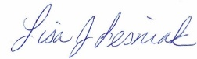

Democratic Women of Boulder County

Since 1962, the DWBC has fomented change: from supporting the campaign of the first woman from Boulder County to run for state house to keeping our voices heard throughout Colorado. By focusing on education, engagement, and electing individuals to improve our quality of life, DWBC positively impacts the policies that affect our local community as well as Colorado.

As a 501(c)(4) nonprofit organization, DWBC is a social welfare civic organization operated exclusively for the promotion of the common good and welfare of our community. Our core values encompass the ideals of social and economic progress for all and robust support of democracy in the United States.

No matter your political affiliation status, gender, age, or ability, as long as you share our core values, you are encouraged to participate in our activities. We look forward to welcoming you into the DWBC family.

Brief History of the DWBC
The Democratic Women of Boulder County (DWBC) compiled a comprehensive history of the organization for the 40th Anniversary celebration in 2002. It was not the first such history, it is just the surviving one. Most of the following content comes from the program for that celebration. The full content of the program will be uploaded to our website. Our program tonight highlights the first 60 years of DWBC including speakers, issues, and fundraising activities.
EARLY YEARS
Democratic Women of Boulder County began as an organization in 1962. This new organization stated its purpose under Article II of the original constitution (Bylaws):
The purpose of the Democratic Women of Boulder County shall be to promote political responsibility through informed and active participation in Democratic Party politics.
The purpose was enlarged in 1971 to read:
The purpose of the DWBC is to create interest in the democratic party among its members and community at large. It tries to do this by discussing political issues, making it possible for the women to meet and hear party leaders and raising money to aid the county organization and to carry out its program. It is hoped that women will eventually want to work as volunteers for the democratic party, either through the DWBC, the Boulder County Central Committee, or for the candidates of their choice. It is the policy of the DWBC not to endorse any particular candidate within the party.

As revised by a vote of membership in 1997, Article II read,
The purpose of the Democratic Women of Boulder County shall be to promote community responsibility and to encourage informed participation in the Democratic Party politics.
In the early years, our name appeared in the Boulder Daily Camera as, “Democratic Women’s Club of Boulder.” In February 1965, we voted unanimously to rename our organization, “Democratic Women of Boulder County.” The group felt that the use of the word “club” made our organization sound exclusionary, and we are not. We agreed to let men be members in the early 1970’s when one member’s son wanted to join.
HOW DID WE RAISE MONEY FOR THE CANDIDATES AND THE PARTY?
- Cookbook sales: 1969 Cookbook called “Cook Stirring Constantly” and 1990 titled “Best of Boulder Cookbook.”
- Bake sales: They played significant fundraising roles throughout the years earning a profit of $286 in 1971.
- Wine sales: One meeting locale did not have a liquor license. An enterprising member brought gallon jugs of wine along and sold the wine for $1 a glass.
- Home tours: Home tours were held in 1965, 1971, and a third a few years later.
- Tea Tastings: Members worked at Celestial Seasonings in the 1980’s and 1990’s and donated their earnings to DWBC.
- Picnics, parties, potlucks, and plays: These events were also successful fundraisers for DWBC through the years.
- Small Donor Committee (SDC): The committee was formed in 2003 to raise funds for candidates.

WHERE DID THE MONEY GO?
- 1972: DWBC funds were used to pay 50% of the salary, with a maximum of $100 per month, to a full-time qualified individual to manage the Boulder County Democratic Headquarters office. DWBC became Century Club members and gave an equal amount of money ($75.00) to 9 candidates.
- October 1984: DWBC divided $3,196 among the Boulder County candidates.
- 1992: DWBC paid the tuition for a CU student and Democrat to attend the Democratic Party’s “Colorado Institute of Leadership Training.”
- 2000: DWBC helped the County Party again by giving them $1,000 to help print and mail the sample ballots.
- 2022: DWBC gave away the most money ever: almost $14,000 to candidates throughout Colorado and $7,000 to other nonprofit organizations who do grassroot work on the ground in districts. Check our website for details.

SPEAKERS AND ISSUES TROUGHOUT THE YEARS 1962 – 2022
- 1965: DWBC visited the Colorado State Legislature in Denver.
- 1970’s: Political Seminars including one with Eleanor McGovern and one on the topic “From Precinct Caucus through National Convention” including Dickey Lee Hullinghorst and Pat Schroeder.
- May 1976: DWBC voted to approve a resolution to strongly support the ERA, the Boulder County and State ERA Organization.
- October 1980: Professor Conrad McBride spoke on the question, “Picking the President – Is It Time to Change the Rules?”
- September 1981: First Lady Dottie Lamm spoke and urged members to “Think Globally and Act Locally.”
- March 1987: 25th Anniversary Celebration honored the founding members of DWBC.
- November 1995: Women’s Suffrage meeting including State Senator Dorothy Rupert, Eleanor Crow, and Maxine Hitchcock reporting on the Beijing Conference on Women.
- May 1996: First Annual DWBC Woman of the Year award given to JoElyn Newcomb, Janet Roberts, and Dorothy Rupert for outstanding accomplishments in the community and advancing the DWBC objectives.
- September 2002: pros and cons of ballot measures were presented including a measure on mail-in ballots.
- February 2008: Governor Howard Dean spoke.
- October 2012: Debate watching party at Rio Grande.
- Fall 2016: Michael Isakoff spoke about his book "Russian Roulette" co-authored with David Corn.
- January 2021: Governor Jared Polis spoke about COVID and its impacts on Colorado.
- September and October 2022: Candidate forum with Sen Bennet, Rep Joe Neguse, and many other local candidates providing us with the most attendance since COVID, with well over 100 attending each meeting.

FOUNDING MEMBERS OF THE DWBC
Louise Adams | June Howard
Jane Allen | Norma Jacobsen
Kate Carter | Carolyn Kieffer
Lonnie Codding | Nancy Kraushaar
Lois Daily | Mary Lind
Millie Danielson | Pauline Lindbloom
Alice Davis | Dorothy London
Imogen Easton | Betty Lovelace
Lucille Fest | Gloria Lund
Helen Fischer  Linda Flack | Mary Maslin
Claudine Garby | Rosemary McBride
Colleen Garby | Mary Margaret Meek
Ruth Greenway | Alberta Morris
Anne Grelle | Dorothy Ogilvy
Virginia Hammond | Margaret Ostrow
Meg Hansson | Joy Paulson
Katherine Hile | Thea Phinney
Bea Hoffman | Vicky Ruwitch

June Sampson
Ruth Scott
Saida Selby
Phyllis Shushan
Aladeen Smith
Joyce Smith
Dorothy Stonebreaker
Dorothy Thompson
Joan Trailbush
Sadie Walton
Janet Weir
Rita Weiss
Marlies West
Reggie Wieder
Sigga Mai Williams
Sue Weatherly
Arlene Wolfe
Katherine Vanderberg
MEMBERSHIP IN DWBC
How to join:
Visit our website https://demwomen.com.
Select “Join Us” button, choose a membership level, enter your email address, check the captcha box, click next, complete the contact information page in full, review, click pay online, use your credit card to make payment.

Always use the email you used to join to login.

Benefits of Membership:
- Becoming part of a community social group of like-minded people and making new friends
- Pooling your membership with others to leverage donations to campaigns and grassroot organizations working to protect democracy
- Reduced monthly meeting fees
- Annual visit to State Capitol to visit legislators

Small Donor Committee
- Your membership dues support our SDC with the first $50 of your membership dues going directly to the SDC.
- Our SDC contributes directly to election campaigns.
- All dues over the first $50 support grassroots organizations such as New Era Colorado and fund operational costs including technology fees, website maintenance, and reducing costs for monthly meetings.

** Donations and Membership dues are NOT tax deductible.**
PRESIDENTS OF THE DWBC
Jan Weir | Kathy Cook
Anne Branscomb | Audrey Enarson
Mary Martin | Bev Sanders
Nancy Kraushaar | Frances Wyrick
Marian Martell | Helen Dorsey
Marion McElwain | Marion Selbin
Janet Roberts | Cynthia Russel
Kay Rock | Barbara Cardell
Alice Winter | Janet Miller-Reynolds
Kay Boyne | Lynn Guissinger
Anna Marie Robb | Edie Hooten
Margaret Holitza | Rita Mahoney
Sherrie Wolff | Laura Sparks
Clela Rorex | Ashley Farrington
Katherine Chandley | Tracy Zaik
Rosemary McBride | Phyllis Rheiner
Vija Handley | Lisa Lesniak
Britta Singer

60th Anniversary Event Committee
Joanna Clark
Cathy James
Barb Knapp
Lisa Lesniak
Kim Matthews
Tina Marquis
Lisa Wade

Table Hosts
Harriet Boonin
Jan Bornstein
Linda Flack
Dita Hutchinson
Barb Knapp
Lisa Lesniak
Tina Marquis
Kim Matthews
Kris Moe
Sandra Shafto
Laura Sparks
Lisa Wade

2022-2023 DWBC Board members
Susan Boucher
Carol Callicotte-Belmon, Secretary
Cathy Carlson
Sharon Conley
Jenn Dempsey
Dave Gross, Treasurer
Dita Hutchinson
Cathy James
Barb Knapp
Lisa Lesniak, President
Tina Marquis, Vice President
Lisa Wade

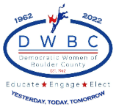

https://demwomenboco.com

